Practical 2

# Aim:

Bit Stuffing and Byte Stuffing

# Bit Stuffing

#include<bits/stdc++.h>

**using** **namespace** std**;**

int main**()**

**{**

string data**;**

string sol**;**

cout**<<**"Enter a string in bits:"**;**

cin**>>**data**;**

int j**=**0**;**

int count**=**0**;**

int n**=**data**.**size**();**

//cout<<n;

**for(**int i**=**0**;**i**<**n**;**i**++)**

**{**

**if(**data**[**i**]==**'0'**)**

**{**

count**=**0**;**

sol**+=**'0'**;**

**}**

**else** **if(**data**[**i**]** **==** '1'**)**

**{**

count**++;**

sol**+=**'1'**;**

**}**

**if(**count**==**5**)**

**{**

sol**+=**'0'**;**

**}**

**}**

cout**<<**"Output is: "**<<**sol**;**

**return** 0**;**

**}**

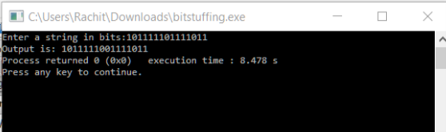

# Byte Stuffing

#include<bits/stdc++.h>

**using** **namespace** std**;**

int main**()**

**{**

char flag**=**'#'**;**

char esc**=**'$'**;**

string data**;**

cout**<<**"Enter a string:"**;**

cin**>>**data**;**

string output**=**"#"**;**

**for(**int i**=**0**;**i**<**data**.**size**();**i**++)**

**{**

**if(**data**[**i**]==**flag**)**

**{**

output**+=**esc**;**

output**+=**flag**;**

**}**

**else** **if(**data**[**i**]==**esc**)**

**{**

output**+=**esc**;**

output**+=**esc**;**

**}**

**else**

**{**

output**+=**data**[**i**];**

**}**

**}**

output**+=**flag**;**

cout**<<**output**;**

return 0;

}

